**LET’S DISCOVER THE MUSEUM**

**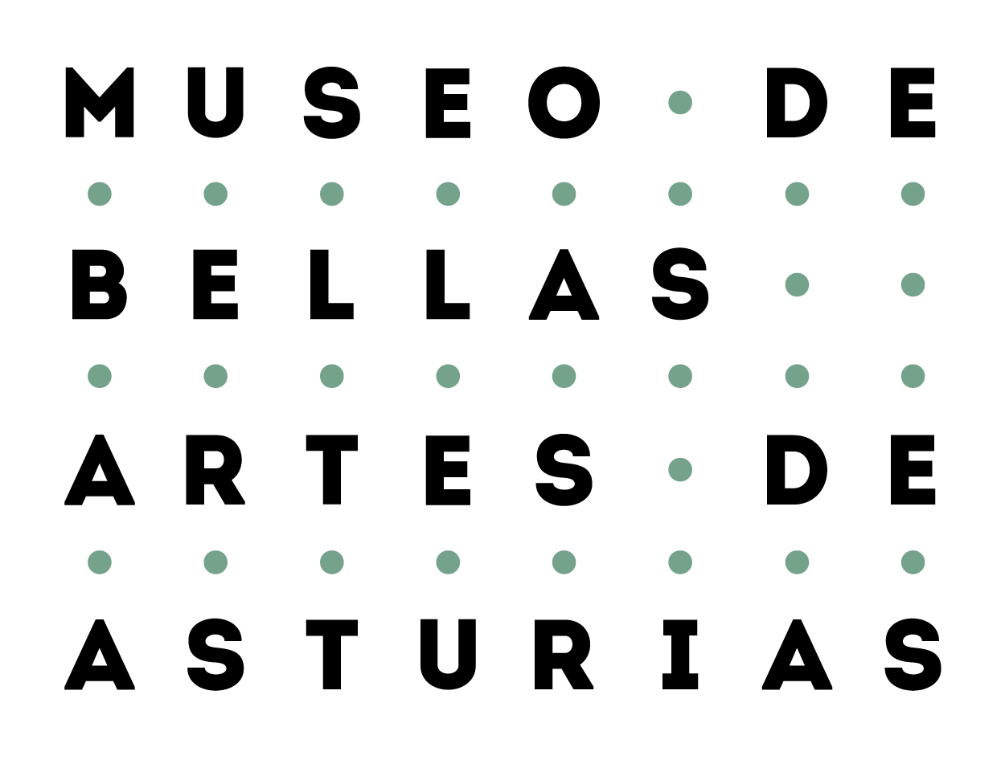** 

The project leading to this application has received funding from the European Union’s Horizon 2020 research and innovation programme under grant agreement No 693229



Do you want to play with us?

This game is divided into three categories:

**discovering** the artworks, feeling **emotions** and **creating.**

Are you ready?

During your visit, you will only have to   
pay attention to the artworks  
 and follow the instructions and questions.

Have fun!

**DISCOVERING THE ARTWORKS**

Do you know who the artist is?

Do you know the story behind this scene?

What do you think is happening?

Tell your friend about it!

How would you know the style of the painting?

You can visit our web page and   
the library to find it out!

Have you seen people dressed like this nowadays?

Have you seen this character depicted in any other way or somewhere else?

Do you know if there are other artworks by the same artist in the museum?

Would you like to go and find them?

Look for artworks that are similar.

Compare them and find the differences!

**FEELING EMOTIONS**

What do you like about this artwork?

Which character from this artwork   
would you like to be?

How do you feel when you see this artwork?

Why?

What would you add or remove to make you feel a different sesation?

**CREATING**

What items or clothing would you like   
to be painted with in a portrait?

How would this artwork be painted nowadays?

Which kind of music do you think would go with   
this artwork?

What do you think the character in the painting   
is thinking?

Take a selfie with the artwork and send it to a friend!

Draw yourself inside the frame and   
share it with your friends!



**AND TO FINISH…**

What do you think about this game?

Would you like to leave a comment or suggestion?

We hope you’ve enjoyed your time with us!

ISBN: 978-3-903312-04-3, ArteConTacto.

The project leading to this application has received funding from the European Union’s Horizon 2020 research and innovation programme under grant agreement No 693229

C:\Users\Bellas Artes\Documents\ARCHES PROYECT\Folleto Arches\flag_yellow_high.jpg