How do I plan my visit to the Museum?
What do I expect from a barrier-free Museum?
used Icons: (https://icons8.com/icons/office)

1
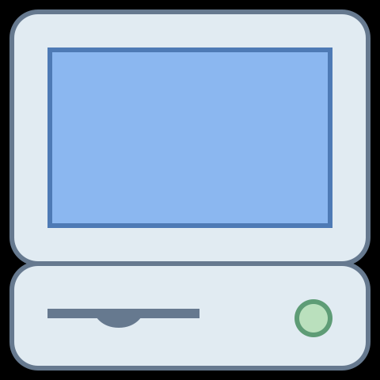 before the visit:

I will inform myself on the homepage of the museum.
All information must be easy to find.
I assume that all publicly accessible rooms are barrier-free.

On the homepage I can choose different settings from the beginning:
simple language
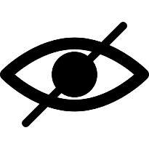 for blind and visually impaired people
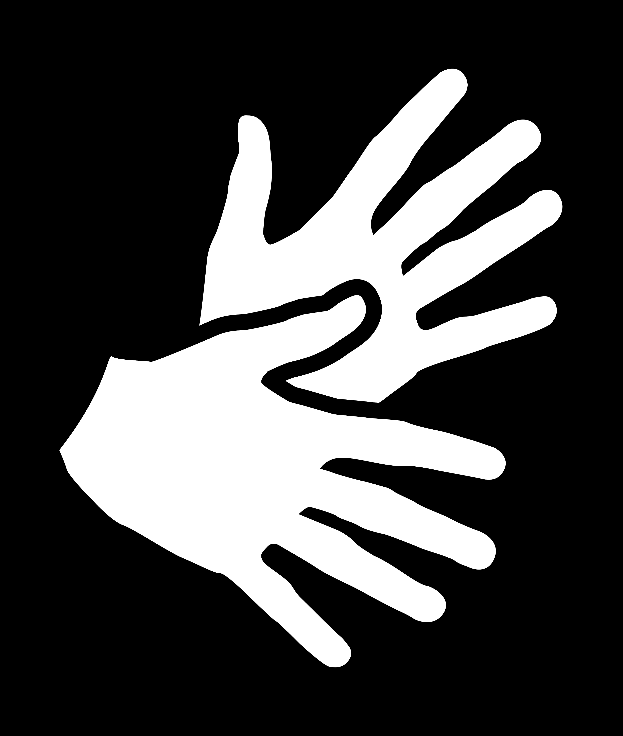 for deaf people and people with hearing impairement
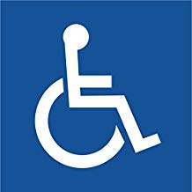 for people with reduced mobility

The logos must be defined setting up the homepage.
Otherwise it does not make sense for blind people.

I want to find the museum's opening hours easily.

I want to find the address of the Museum easily.
I want a description of how to reach the Museum.

Admission prices should be clearly arranged.
I would like to see the reduced fees clearly.

A disabled parking aerea should be offered.
A precise description of how to find is important.

I would like a contact person who can be reached every day during opening hours (e-mail and telephone number) (at the KHM the Guest Service is responsible for this).

I would like a clearly visible link to the events.

2
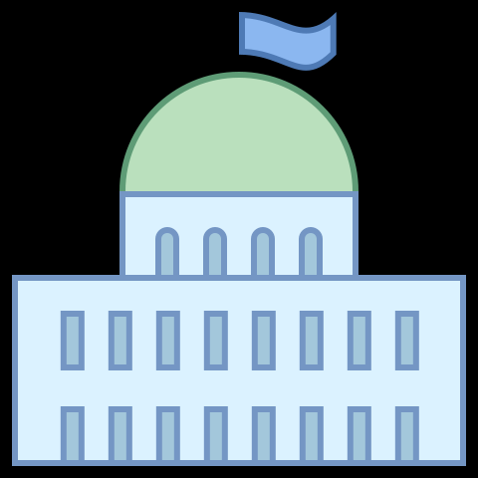 Arrival at the Museum:

When I arrive at the Museum, I don't need barrier-free information in front of the Museum.
But on the ground in front of the main entrance I absolutely need attention fields. (Note: such fields are regulated by standard)
I would like to know which of the existing entrance doors is open.

In the case of the KHM, handrails are missing (regulated by standard).
The entrance door should open automatically.

3
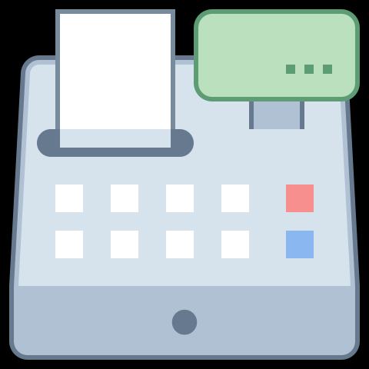 Ticket office:

The ticket offices must be clearly visible.
Good lighting is very important.
On the ground, I need guidelines that guide me from the entrance to the ticket offices.
The guidelines should also lead to the entrance hall and to the information desk.

If no guidance system is possible, an assistant should be directly at the cash desk.
All information at the cash desk should be in sign language for deaf people.
´
Maybe you can introduce a handicap card.
If you show it, the staff will know that this visitor needs special support.
This card would be very helpful for deaf people.
Because these visitors can hardly make themselves understood.

4
Entrance, ticket control

The entrance and exit must also be clearly marked in the interior of the Museum.
Good lighting is important.
The wardrobe and lift signs must be clearly visible.

5
Wardrobe:

The access to the wardrobe must be clearly visible.
The lockers should be changed.
A jeton should be used instead of a coin.

6
Galleryrooms, exhibiton aerea:

All exhibition areas must be barrier-free.
The lift needs to be very well lit.
The labels must be tactile.
The lift must have a voice output.

There should be barrier-free information about the rooms and objects (big letters, good colour contrasts).
An audio guide in simple language would be very good.
These texts should also be available on the museum's homepage.

I would like to get a regular offer of barrier-free guided tours.
The tour dates should be announced far in advance.
On the homepage there will be a special area for guided tours for people with disabilities.
In the printed program there should be a separate page for this.
The title could be: Guided tours for people with disabilities interested in art
You can also create a special newsletter or e-mail distribution list.
So you would get a mailing list.

The fees for the tours should be low (they are currently free of charge for people with disabilities at the KHM).

The tours should be in simple language.

7
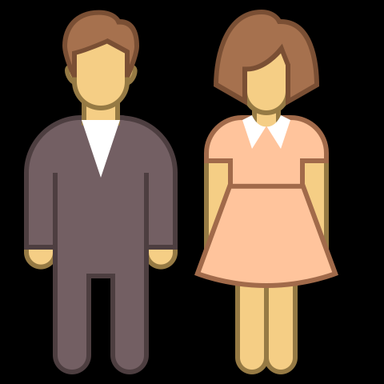 Toilets

Barrier-free accessibility is particularly important here.
Check the dimensions of the doors!
The doors are usually very narrow.
However, wheelchairs are becoming more and more compact.
You should be able to find these dimensions easily on the homepage.

8
Shop:

On the homepage the shop must be barrier-free.
The Voice over function must be stable.
It should be easy to place orders online.
Personal support in the Museum is very important.

9
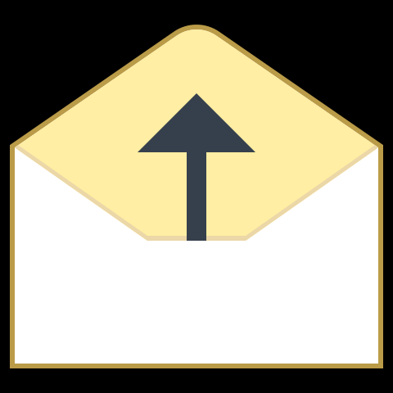 Feedback:

If there is no information desk yet, one should be set up.
There you can give your opinion orally and in writing.

How do deaf people do that?
These people do not like to speak because they are poorly understood.
They cannot write well either.
Therefore no special e-mail address helps them.
They can record messages (mobile phone, tablet, iPad).
They can make video recordings with sign language.
But who edits this data?
We have not yet found a good solution to this question.

10
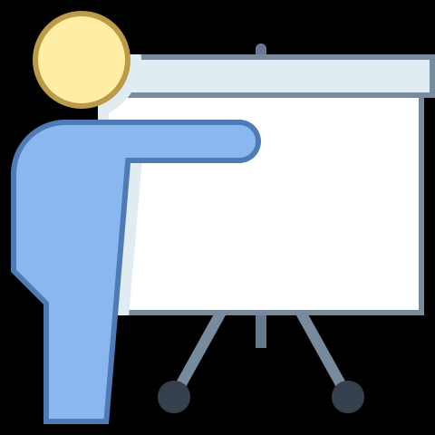 Training of the museum staff:

All the people who deal with the visitors in the museum should be well trained.
The training should take place regularly.
The training should take place in cooperation with representatives of the people concerned.

