PRESS RELEASE Madrid, Oct 30, 2019
European museums go barrier-free with EU-funded 3D art replicas, mobile phone apps, games and sign language video avatars

Six museums, four tech companies and two universities have come together in an ambitious EU-funded research project intended to make art accessible for all. State-of-the-art tactile reliefs made with the latest 3D modelling techniques, barrier-free apps and games for smartphones and tablets, together with sign-language avatars are the cutting-edge technologies proposed by the Arches Team. They will be showcased at the Thyssen-Bornemisza National Museum, in Madrid, on 7 November. The technologies have been co-designed and tested by more than 200 disabled people in Spain, Austria and the UK.

London’s Victoria & Albert Museum, Vienna’s Kunsthistorisches Museum, and Madrid´s Thyssen-Bornemisza are part of this consortium, which has teamed up with people with visual impairments and people with hearing impairments, as well as people with learning disabilities for three years. The work has been carried out within the framework of a €3.8 million research project financially supported by the EU. The initiative was intended to anchor accessibility in the art world and make museums more inclusive spaces.

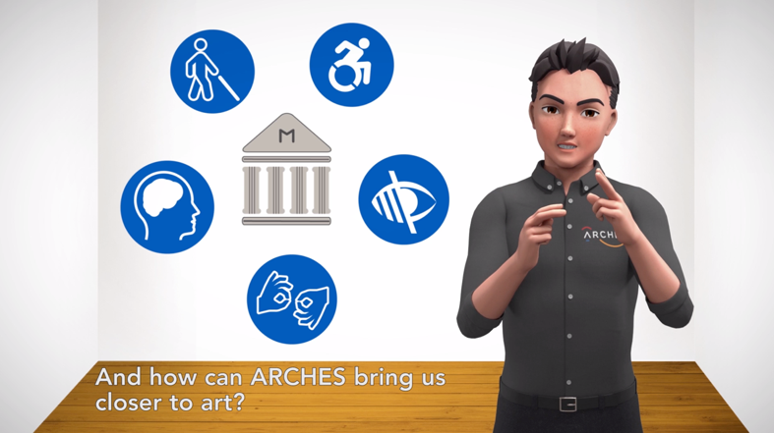
The project is truly unique as it combines international collaboration and participatory research methodology with the development of technology intended to facilitate accessibility for all museum visitors. The team has used a multi-sensory approach to support all people to better experience the great artworks of famous painters, such as Edward Hopper, Frans Hals, and Pieter Brueghel.

The avatar in the ARCHES App speaks sign language.
Inclusive solutions for immersive art experiences
From the outset the research team realised that people’s needs do not neatly fit into traditional categories, such as blind, deaf or learning difficulties. So their focus has been upon the tools people can use, their access preferences, such as audio-description, sign-language, simplified information, or step-free access.
The project has developed tactile reliefs allowing museum visitors to touch masterpieces' replicas placed by the original art work. A relief printer prototype has been filed for patents.
An innovative gesture-controlled multimedia guide is also proposed. The guide reacts to the movement of hands and expands the possibilities of interaction with the artwork by providing information on and around the exhibit - as an audio file, as easy read text, or through sign-language clips. Animations and sound effects round off the offer and are especially child-friendly.
The team has also developed an app that leads the visitor through the museum, using audio description, sign language videos that have been shaped according to the needs of the research groups, and barrier-free games that can be used inside and outside the museum.
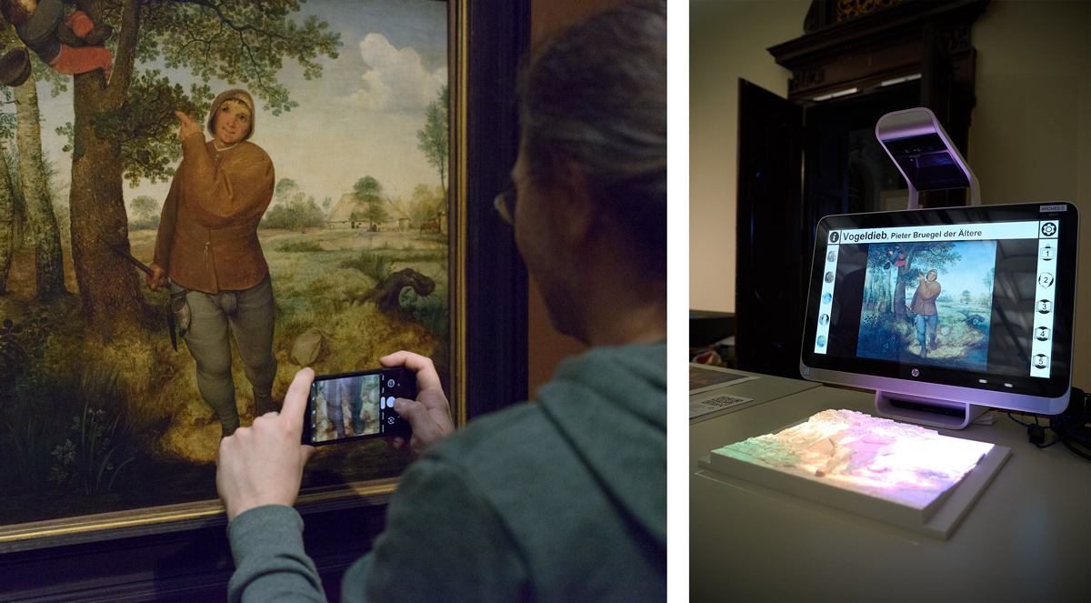

The painting "The Bird Thief" by Pieter Bruegel the Elder & the gesture-controlled multimedia guide with the accompanying tactile relief.
At the crossroads of art, science and technology
The consortium consists of six museums (The Victoria and Albert Museum and the Wallace Collection in London, Kunsthistorisches Museum Wien in Vienna, the Lázaro Galdiano Museum and the Thyssen-Bornemisza National Museum in Madrid and the Asturias Fine Arts Museum), four technology companies from Austria, Serbia and Spain (VRVis, ArteConTacto, SignTime and Coprix) and two universities (Open University and Bath University).

Further findings and results
A manifesto for museum access has been written and videos have been produced by the disabled researchers, to make museum professionals and the broad public aware of their needs. They have also produced a range of guidance and training materials for in-museum activities, including touch maps. A guide for museum professionals on how to work towards a more inclusive museum has also been produced.
The final event of the project will be held on November 7 in Madrid, within the framework of a day of talks and round tables at the Thyssen-Bornemisza National Museum. More than 20 members of the research groups will present the methodology and results, together with the museum educators and the technological companies. There will be simultaneous translation into English and interpretation into Spanish Sign Languages (LSE).

Please find photos and rushes free of charge in the Press section of the ARCHES website: https://www.arches-project.eu/press/

We are happy to arrange ad hoc interviews of participants, developers, and museum professionals in advance.

PRESS CONTACTS:
ARCHES Communication Manager:
Moritz Neumüller press@arches-project.eu / +34-605641118
Museo Nacional Thyssen-Bornemisza:
prensa@museothyssen.org / +34-913 600 236

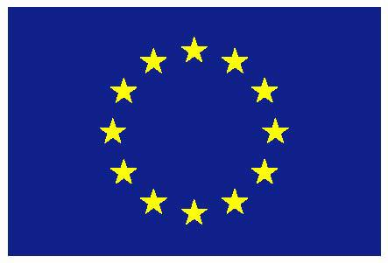
This project has received funding from the European Union’s Horizon 2020 research and innovation programme under grant agreement number 693229. This press release solely represents the consortium´s own views. The European Commission (EC) is not responsible for any use that may be made of the information it contains. An independent technical assessment of the work effectively carried out will be formally commissioned by the services in charge for project implementation as of 8 November 2019.
Annex: Event agenda, Nov. 7, 2019
10:00‐11:00 | Arrival at Thyssen‐Bornemisza National Museum. Inscription and coffee in front of auditorium.
11:00 | Welcome from the Thyssen Museum (Guillermo Solana, Director of the Museum) and project leader (Gerd Hesina, VRVis, Vienna).
11:10 | Presentation Video + Introduction to ARCHES  (by Jonathan Rix, Research Manager)
11:30 | Presentation of the research groups (Helena García Carrizosa, with participants from London, Oviedo, Madrid and Vienna). Round table on the methodology and projects carried out by the participants.
12:30 | Presentation of tactile reliefs, multimedia guide and relief printer (patent pending).  Time for interviews with the press (please arrange in advance)
13:15‐14:15 | Light Lunch in the Mirador
14:30 | Presentation of the How‐To Guide, useful documents, and workshops. (by the authors, and the ARCHES Communication Manager).  Overcoming challenges in the museum: Lorena Palomar with participants from the Oviedo group.
15:30‐15:45 | Coffee break
16:00 | Presentation of the Apps and games, by the tech companies SignTime and Coprix, with participants of the research groups.
17:00 | Q&A and closing
Location: Museo Thyssen-Bornemisza, Paseo del Prado, 8, 28014 Madrid

